Experiment 2

Network Topology creation using Scilab
Name: Muthu Venkatesh M
Reg no:24BCE1389
PART 1:
CODE:
clc;
clear;
close;

n = 25;

edges = [
1 2; 1 3; 1 4; 1 5; 1 6; 1 7; 1 8;
9 10; 10 11; 11 12; 12 13; 13 14; 14 15; 15 16; 16 9;
17 18; 17 19; 18 20; 18 21; 19 22; 19 23; 21 24; 21 25;
8 9;
16 17
];

coords = rand(2, n);

scf(1);
clf();
a = gca();
a.data_bounds = [0 0; 1.2 1.2];
a.box = "on";
for k = 1:size(edges,1)
i = edges(k,1);
j = edges(k,2);

xpoly([coords(1,i) coords(1,j)], [coords(2,i) coords(2,j)]);
e = gce();

if (i <= 8 & j <= 8) then
e.foreground = 2; // Star edges
elseif (i >= 9 & i <= 16) then
e.foreground = 3; // Ring edges
elseif (i >= 17) then
e.foreground = 4; // Tree edges
else
e.foreground = 5; // Hybrid links
end

xm = (coords(1,i) + coords(1,j)) / 2;
ym = (coords(2,i) + coords(2,j)) / 2;
xstring(xm, ym, string(k));
end
for i = 1:n
xfarc(coords(1,i)-0.015, coords(2,i)-0.015, 0.03, 0.03, 0, 360*64);
c = gce();

if i <= 8 then
c.foreground = 2; // Star nodes
elseif i <= 16 then
c.foreground = 3; // Ring nodes
else
c.foreground = 4; // Tree nodes
end

xstring(coords(1,i)+0.02, coords(2,i)+0.02, string(i));
end

deg = zeros(1,n);
for k = 1:size(edges,1)
deg(edges(k,1)) = deg(edges(k,1)) + 1;
deg(edges(k,2)) = deg(edges(k,2)) + 1;
end

disp("Node Number of Edges");
for i = 1:n
disp([i deg(i)]);
end

[maxEdges, maxNode] = max(deg);
disp("Node with maximum edges:");
disp(maxNode);
disp("Maximum edges:");
disp(maxEdges);

disp("Total number of nodes:");
disp(n);
disp("Total number of edges:");
disp(size(edges,1));
OUTPUT:
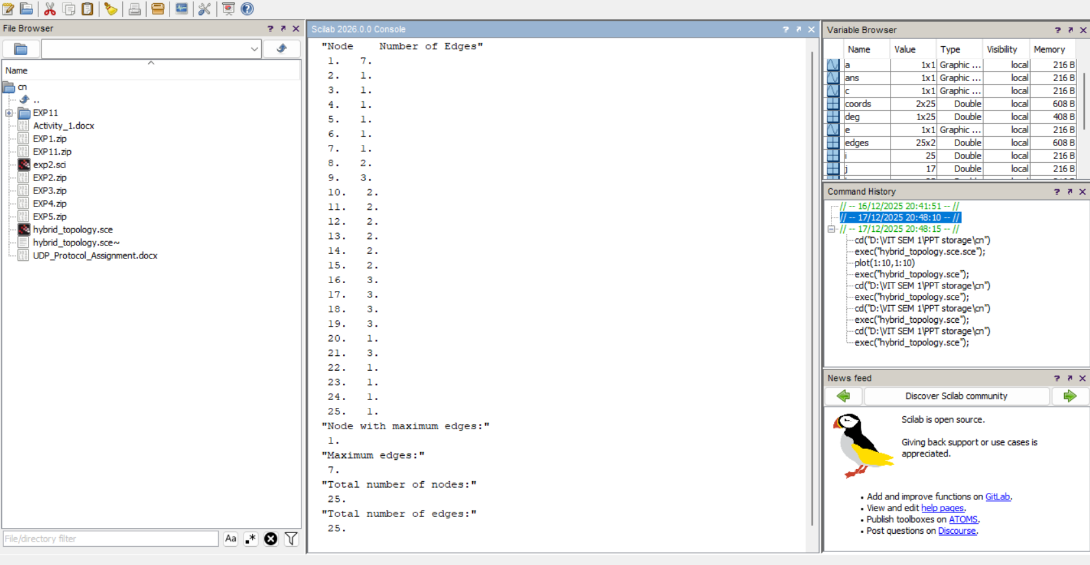
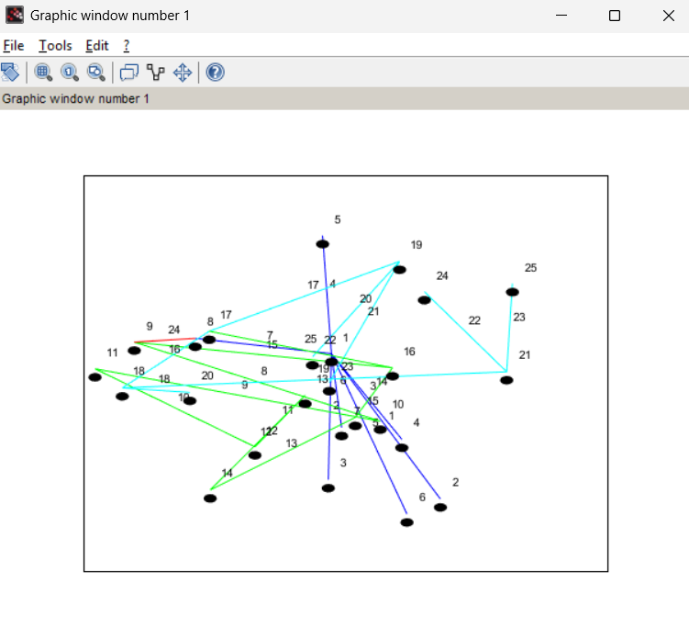
PART B:
A large university campus network is designed using a hybrid topology to efficiently manage communication among different departments.
- The Administration Block uses a Star topology where one central server connects multiple offices for fast decision-making.
- The Academic Blocks are connected using a Ring topology to ensure equal data access and continuous communication between departments.
- The Hostel and Residential Area follows a Tree topology to support hierarchical data distribution across multiple buildings and floors.
- To ensure seamless communication across the campus, the Star, Ring, and Tree topologies are interconnected, forming a hybrid network with 25 nodes.
Each node represents a network device such as a router, switch, or workstation, and each edge represents a communication link.

Questions:
- Identify the type of network topology used in the campus network and justify why a hybrid topology is suitable for this scenario.
- Determine the total number of nodes and edges in the network.
- Calculate the degree of each node and identify the node with the maximum number of connections.
Explain why this node plays a critical role in the network.

